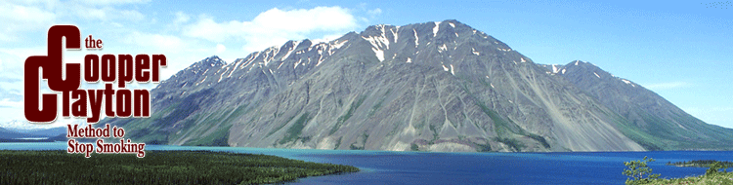
Success rate is 40-45% versus 5-15% quitting on your own!
FREE & Open to the Public!
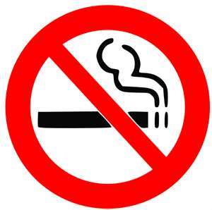
Become a non-smoker! FREE classes!

The Cooper/Clayton Method to Stop Smoking is an effective smoking cessation method which addresses all aspects of smoking. The Method uses the nicotine patch, nicotine gum, and the nicotine lozenge and it provides 13-intensive education sessions and weekly support group meetings. Facilitators are trained in the method, and will lead group discussions, focusing on understanding behavior modification techniques and how to minimize relapse.
The only cost to the participant is the cost of the nicotine patches, nicotine gum or the nicotine lozenge. Classes are FREE, open to the public and will meet for one hour, once a week.

Available Classes:
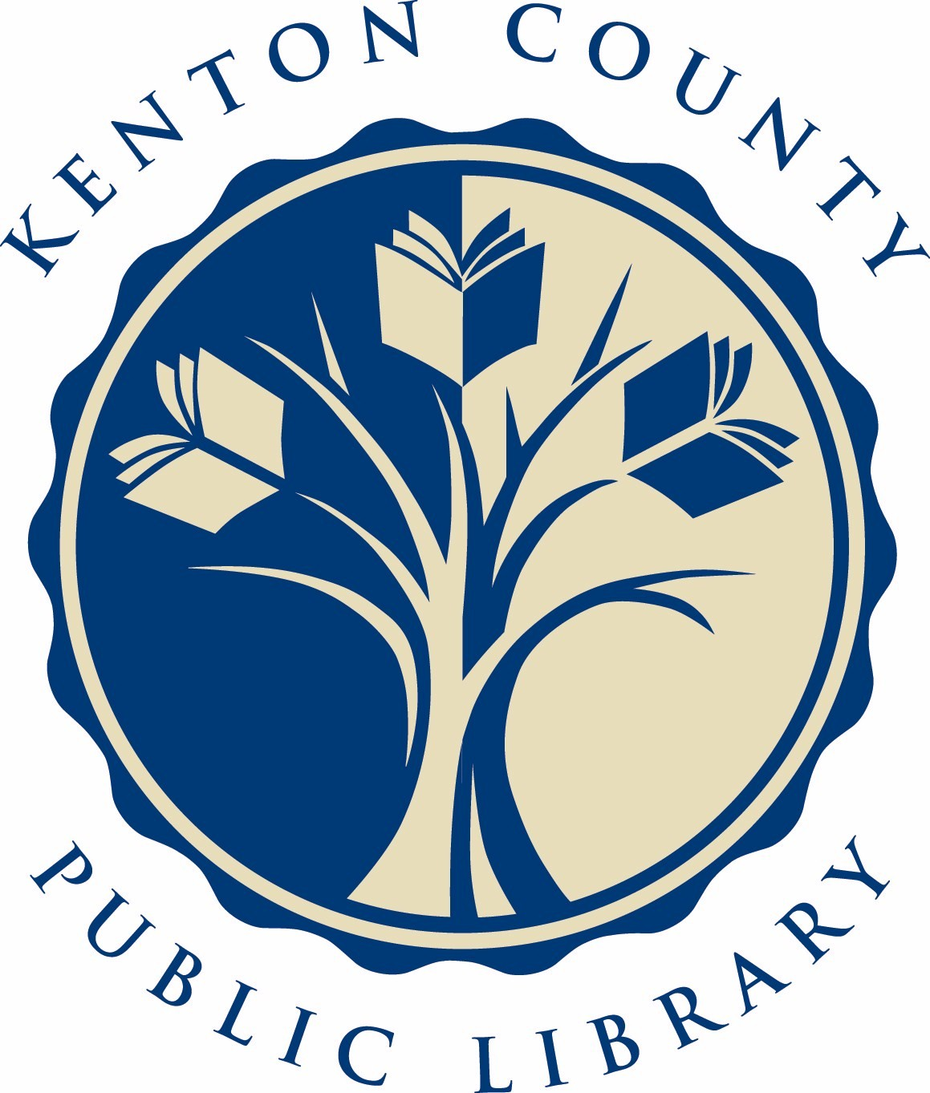
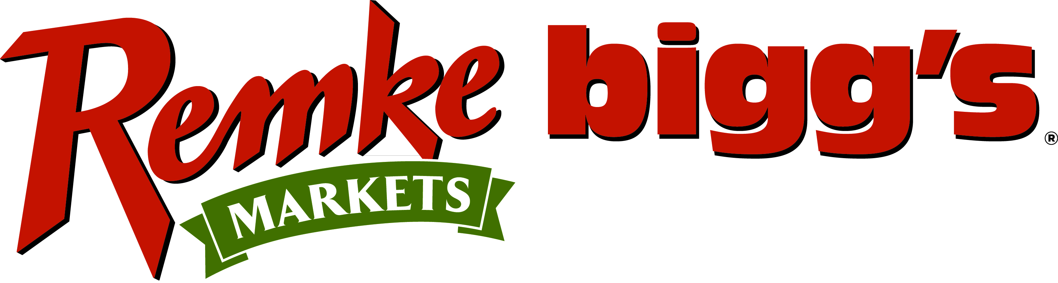
OHIO  Remke bigg’s Hyde Park  3872 Paxton Ave, Cincinnati, OH 45209  513-619-5454  Thursday’s, 4:30 – 5:30PM  February 28 – May 23, 2013  Remke bigg’s Delhi  5025 Delhi Rd, Cincinnatim Oh 45238  513-231-0606  Tuesday’s 9:00 – 10:00AM  February 26 – May 21, 2013  Register: wellness@remkes.com . or 859-594-3400 x0 | .  .  .  .  .  .  .  .  .  . | KENTUCKY  Kenton County Public Library  401 Kenton Lands, Erlanger, KY 41018  859-962-4000  Monday’s 6:00 – 7:00PM  February 25 – May 20, 2013  Register: www.kentonlibrary.org/events  or  859-962-4002  All classes facilitated by
For additional classes contact Cooper/Clayton Hot Line: 859-301-5570.
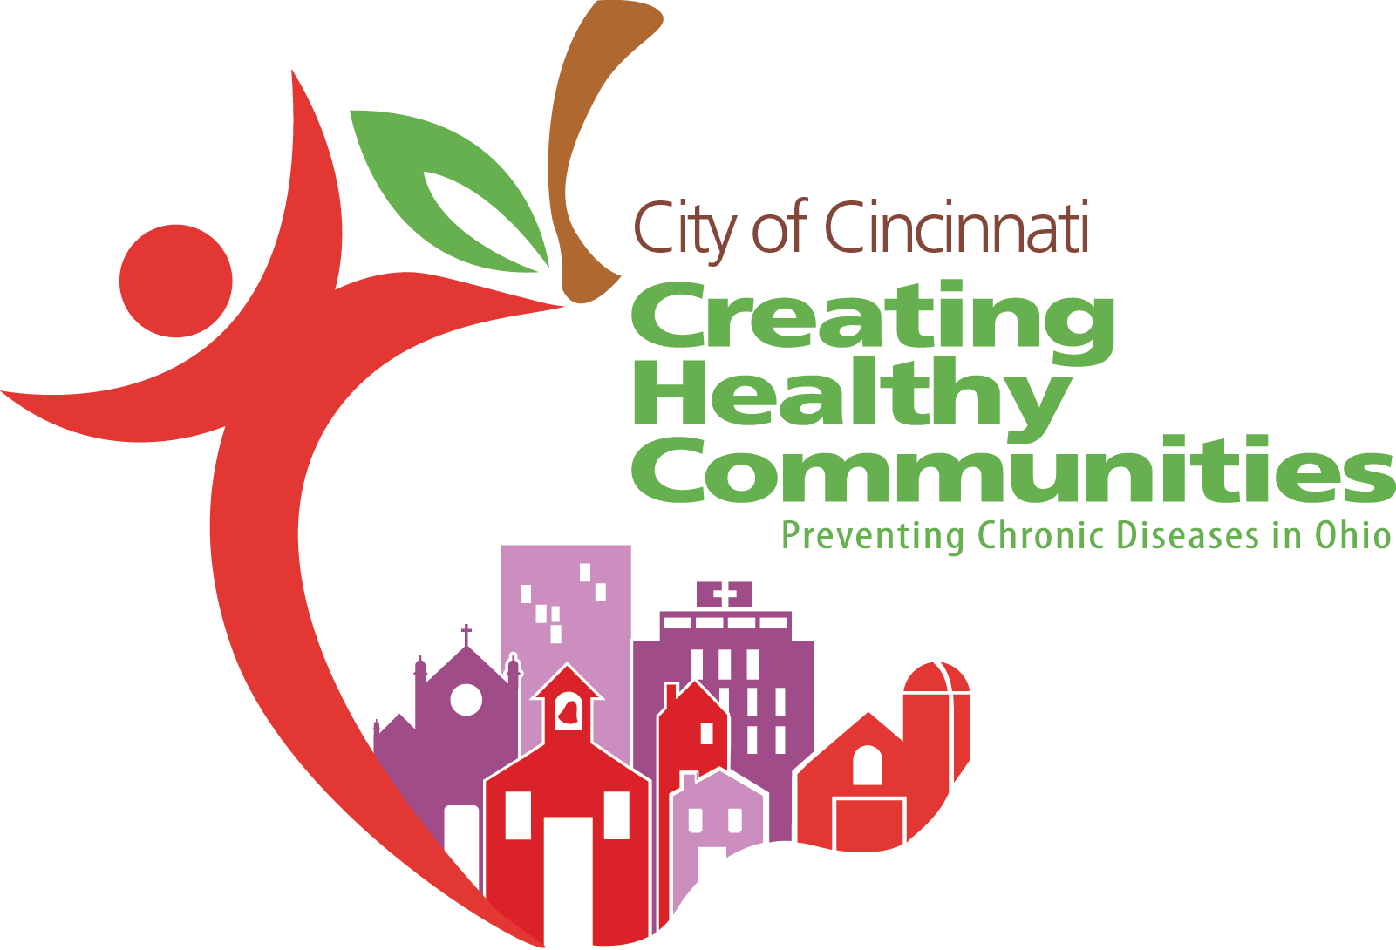
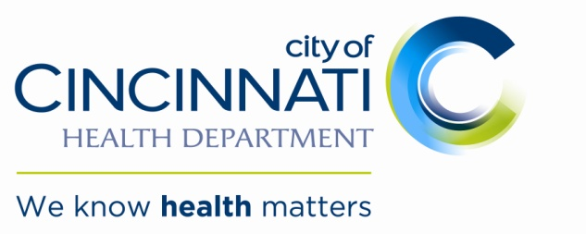
Additional free support if you are thinking of quitting, call 1-800-QUIT-NOW.
